Online Payment by Credit Card via email
Introduction

We accept Visa, Mastercard, American Express, JCB through internet. After receiving your booking, we will send you an invoice for payment by email. Kindly follow the following instructions to complete the payment process.

- Click payment link after receiving email.
- Review invoice
Check the information of the Order. If all information is correct, please check the link “Terms and Conditions” and click “I agree with Terms and Conditions”.
Then click “CHECK OUT TO PAY”.
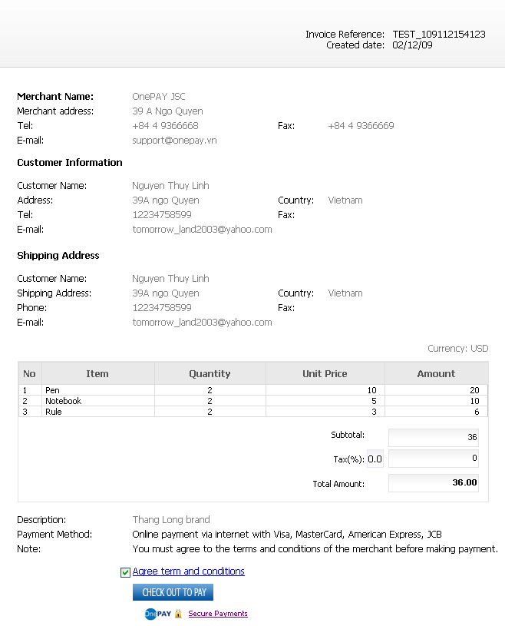
You will be redirected to OnePAY Payment Gateway to pay us online with Visa, MasterCard, American Express, and JCB Card with the next steps:

- Card information input:

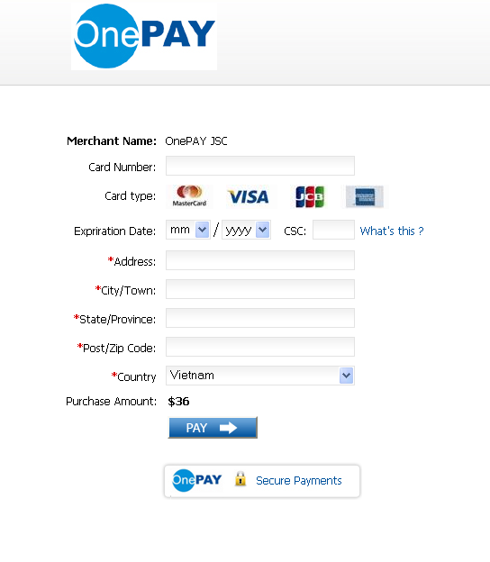
To make the payment, you will input the following card information:
- Card Number
- Expiry Date
- Security Code – CVV, CVC
- Billing address (Card holder’s address which has been registered with the Issuer Bank)
- Online payment password (If you have enrolled 3D- Secure Program for your card with the Issuer Bank namely Verified by Visa for Visa card, MasterCard Secure Code for MasterCard, and J- Secure for JCB Card ).
Click PAY.

- Transaction Result
You would kindly wait for some seconds for the transaction result from OnePAY payment gateway.
If the payment is successful, you will see the notification: Your invoice was paid successfully!
If the payment is failed, you will see: Transaction was not successful!
We will also send you an email to inform you the Order status and the transaction result.

Note
In some cases, your transaction may be not successful due to:
- In correct card information
- Not enough credit balance (daily or monthly)
- Your card has not been activated for online payment. You should contact the Issuer Bank for the card activation.

In case you input card information then did not receive any transaction result from the payment gateway or from us. Please do not try to make other payment. Contact us to get the transaction result and confirmation of the Order

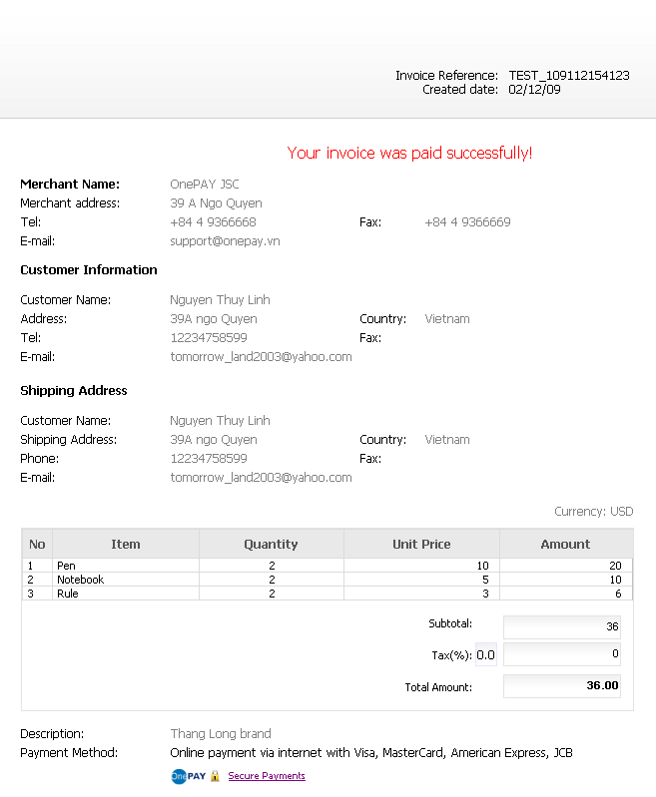

About OnePAY:
OnePAY represents MasterCard to provide online payment solution to the enterprises in Vietnam. Payment portal system of OnePAY is trusted by big banks in the world such as ANZ, HSBC, ICICI, Standard Charter. OnePAY payment portal meets standards of international financial system such as PCI DSS of PCI Security Standards Council, 3D-Secure of Visa, MasterCard and JCB. For more information, please visite website: www.onepay.vn

Section: ……….…...
Tel: …….……...
Email: …. ….…….
(Merchant’s support contact)

